Review Questions:

5.2; Factoring
Factoring:
x² – 4x + 3 x² + 13x + 40 x² – 16x + 51
(x – 3)(x -1) (x + 5)(x + 8) cannot be factored

2x² + 7x + 3 8x² + 18x + 9 6x² – 9x + 5
(2x + 1)(x + 3) (4x + 3)(2x + 3) cannot be factored

Special patterns;
16t² – 9 4r² – 4r + 1 5x² + 5x – 10
(4t – 3)(4t + 3) (2r – 1)² 5(x + 2)(x – 1)

5.3; Radicals
Simplify the radical:
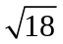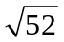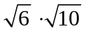
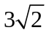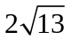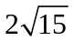

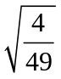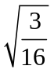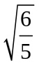
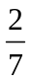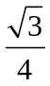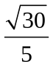

Solve:
x² = 90 3x² = 108 -x² – 12 = -87
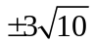 x = -6, 6 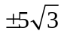

5(x – 7)² = 135
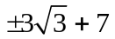

5.4; Complex Numbers
Solve
2x² + 9 = -41 9(w – 4)² + 1 = 0
+/- 5i 4 +/- (1/3)i

Add/Subtract
(-1 – i) + (9 – 3i) (30 – i) – (18 + 6i) + 30i
8 – 4i 12 + 23i

Multiply/Divide
(5 + i)(8 + i) 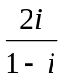
39 + 13i -1 + i

5.5; Complete the Square
x² + 2x = 9 x² + 3x – 1 = 0
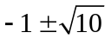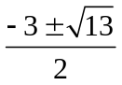

2x² – 12x = -14 -4r² + 21r = r + 13
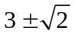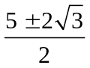

Any Method:
x² + 4x – 12 = 0 2x² + 9x + 7 = 0 x² – 6x – 15 = 0
-6, 2 -7/2, -1 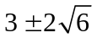

5.6; Quadratic Formula
Solve
x² – 5x – 14 = 0 2x² + x + 1 = 0 10v² + 8v – 1 = 0
-2, 7 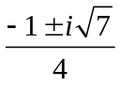 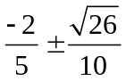

-x² = 16x + 46 8x² – 8x = 1 40x – 7x² = 101 – 3x²
